3GPP TS 45.004 V4.0.0 (2001-04)
Technical Specification
3rd Generation Partnership Project;
Technical Specification Group GSM/EDGE
Radio Access Network;
Digital cellular telecommunications system (Phase 2+);
Modulation
(Release 4)


The present document has been developed within the 3rd Generation Partnership Project (3GPP TM) and may be further elaborated for the purposes of 3GPP.
The present document has not been subject to any approval process by the 3GPP Organizational Partners and shall not be implemented.
This Specification is provided for future development work within 3GPP only. The Organizational Partners accept no liability for any use of this Specification.
Specifications and reports for implementation of the 3GPP TM system should be obtained via the 3GPP Organizational Partners' Publications Offices.

Keywords
Digital cellular telecommunications system, Global System for Mobile communications (GSM)
3GPP
Postal address

3GPP support office address
650 Route des Lucioles - Sophia Antipolis
Valbonne - FRANCE
Tel.: +33 4 92 94 42 00 Fax: +33 4 93 65 47 16
Internet
http://www.3gpp.org
Copyright Notification
No part may be reproduced except as authorized by written permission.
The copyright and the foregoing restriction extend to reproduction in all media.

© 2001, 3GPP Organizational Partners (ARIB, CWTS, ETSI, T1, TTA,TTC).
All rights reserved.
Contents
Foreword 4
0 Scope 4
1a References 4
1b Abbreviations 4
2 Modulation format for GMSK 4
2.1 Modulating symbol rate 4
2.2 Start and stop of the burst 4
2.3 Differential encoding 4
2.4 Filtering 4
2.5 Output phase 4
2.6 Modulation 4
3 Modulation format for 8PSK 4
3.1 Modulating symbol rate 4
3.2 Symbol mapping 4
3.3 Start and stop of the burst 4
3.4 Symbol rotation 4
3.5 Pulse shaping 4
3.6 Modulation 4
Annex A (informative): Change control history 4

Foreword
This Technical Specification has been produced by the 3rd Generation Partnership Project (3GPP).
The contents of the present document are subject to continuing work within the TSG and may change following formal TSG approval. Should the TSG modify the contents of the present document, it will be re-released by the TSG with an identifying change of release date and an increase in version number as follows:
Version x.y.z
where:
x the first digit:
1 presented to TSG for information;
2 presented to TSG for approval;
3 or greater indicates TSG approved document under change control.
y the second digit is incremented for all changes of substance, i.e. technical enhancements, corrections, updates, etc.
z the third digit is incremented when editorial only changes have been incorporated in the document.

0 Scope
The modulator receives the bits from the encryption unit, see GSM 05.01 [1], and produces an RF signal. The filtering of the Radio Frequency (RF) signal necessary to obtain the spectral purity is not defined, neither are the tolerances associated with the theoretical filter requirements specified. These are contained in GSM 05.05 [4].

1a References
The following documents contain provisions which, through reference in this text, constitute provisions of the present document.
- References are either specific (identified by date of publication, edition number, version number, etc.) or non-specific.
- For a specific reference, subsequent revisions do not apply.
- For a non-specific reference, the latest version applies. In the case of a reference to a 3GPP document (including a GSM document), a non-specific reference implicitly refers to the latest version of that document in the same Release as the present document.
[1] GSM 01.04: "Digital cellular telecommunication system (Phase 2+); Abbreviations and acronyms".
[2] GSM 05.01: "Digital cellular telecommunication system (Phase 2+); Physical layer on the radio path General description".
[3] GSM 05.02: "Digital cellular telecommunication system (Phase 2+); Multiplexing and multiple access on the radio path".
[4] GSM 05.05: "Digital cellular telecommunication system (Phase 2+); Radio transmission and reception".

1b Abbreviations
Abbreviations used in this specification are listed in GSM 01.04 [1]

2 Modulation format for GMSK

2.1 Modulating symbol rate
The modulating symbol rate is 1/T = 1 625/6 ksymb/s (i.e. approximately 270.833 ksymb/s), which corresponds to 1 625/6 kbit/s (i.e. 270.833 kbit/s). T is the symbol period.

2.2 Start and stop of the burst
Before the first bit of the bursts as defined in GSM 05.02 [3] enters the modulator, the modulator has an internal state as if a modulating bit stream consisting of consecutive ones (di = 1) had entered the differential encoder. Also after the last bit of the time slot, the modulator has an internal state as if a modulating bit stream consisting of consecutive ones (di = 1) had continued to enter the differential encoder. These bits are called dummy bits and define the start and the stop of the active and the useful part of the burst as illustrated in figure 1. Nothing is specified about the actual phase of the modulator output signal outside the useful part of the burst.
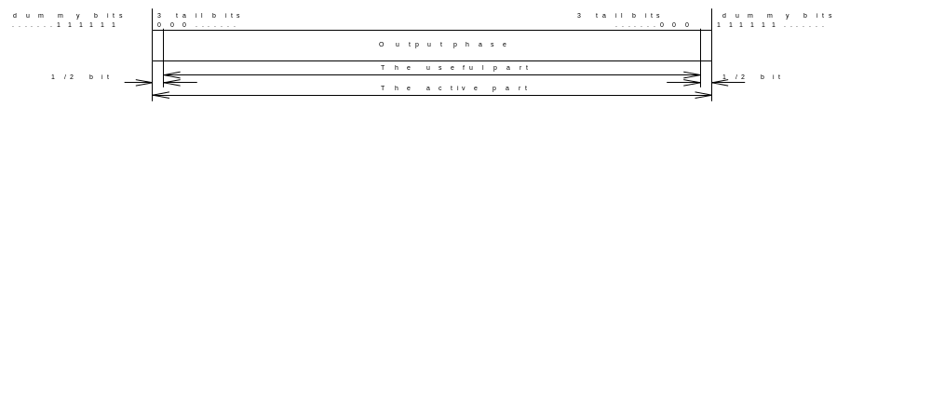
Figure 1: Relation between active part of burst, tail bits and dummy bits. For the normal burst the useful part lasts for 147 modulating bits

2.3 Differential encoding
Each data value di = [0,1] is differentially encoded. The output of the differential encoder is:
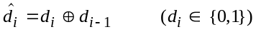
where ⊕ denotes modulo 2 addition.
The modulating data value αi input to the modulator is:
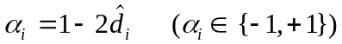

2.4 Filtering
The modulating data values αi as represented by Dirac pulses excite a linear filter with impulse response defined by:
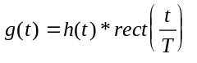
where the function rect(x) is defined by:
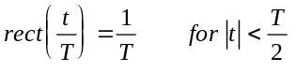
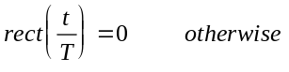
and * means convolution. h(t) is defined by:
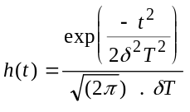

where 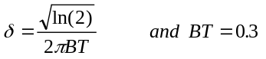
where B is the 3 dB bandwidth of the filter with impulse response h(t). This theoretical filter is associated with tolerances defined in GSM 05.05 [4].

2.5 Output phase
The phase of the modulated signal is:
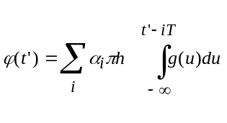
where the modulating index h is 1/2 (maximum phase change in radians is π/2 per data interval).
The time reference t' = 0 is the start of the active part of the burst as shown in figure 1. This is also the start of the bit period of bit number 0 (the first tail bit) as defined in GSM 05.02 [2].

2.6 Modulation
The modulated RF carrier, except for start and stop of the TDMA burst may therefore be expressed as:
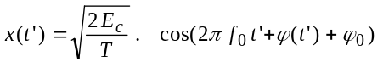
where Ec is the energy per modulating bit, f0 is the centre frequency and ϕ0 is a random phase and is constant during one burst.

3 Modulation format for 8PSK

3.1 Modulating symbol rate
The modulating symbol rate is 1/T = 1 625/6 ksymb/s (i.e. approximately 270.833 ksymb/s), which corresponds to 3*1 625/6 kbit/s (i.e. 812.5 kbit/s). T is the symbol period.

3.2 Symbol mapping
The modulating bits are Gray mapped in groups of three to 8PSK symbols by the rule
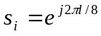
where l is given by table 1.
Table 1: Mapping between modulating bits and the 8PSK symbol parameter l.
Modulating bits  d_{3i},, d_{3i+1}, d_{3i+2} | Symbol parameter l
(1,1,1) | 0
(0,1,1) | 1
(0,1,0) | 2
(0,0,0) | 3
(0,0,1) | 4
(1,0,1) | 5
(1,0,0) | 6
(1,1,0) | 7

This is illustrated in figure 2.
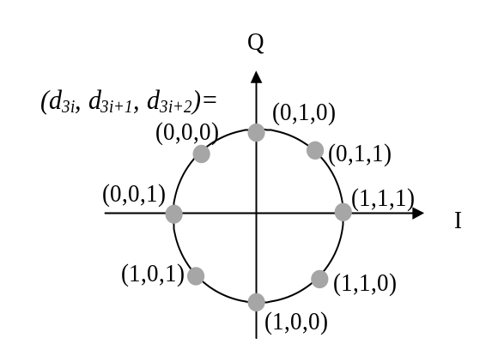Figure 2: Symbol mapping of modulating bits into 8PSK symbols.

3.3 Start and stop of the burst
Before the first bit of the bursts as defined in GSM 05.02 [3] enters the modulator, the state of the modulator is undefined. Also after the last bit of the burst, the state of the modulator is undefined. The tail bits (see GSM 05.02) define the start and the stop of the active and the useful part of the burst as illustrated in figure 3. Nothing is specified about the actual phase of the modulator output signal outside the useful part of the burst.
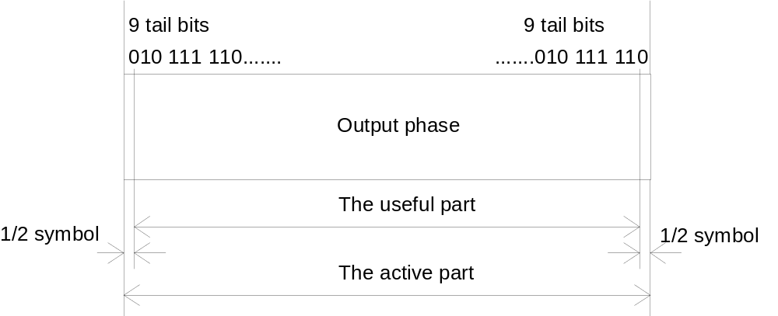
Figure 3: Relation between active part of burst and tail bits. For the normal burst the useful part lasts for 147 modulating symbols

3.4 Symbol rotation
The 8PSK symbols are continuously rotated with 3π/8 radians per symbol before pulse shaping. The rotated symbols are defined as
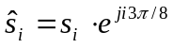

3.5 Pulse shaping
The modulating 8PSK symbols as represented by Dirac pulses excite a linear pulse shaping filter. This filter is a linearised GMSK pulse, i.e. the main component in a Laurant decomposition of the GMSK modulation. The impulse response is defined by:
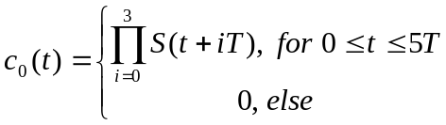
where
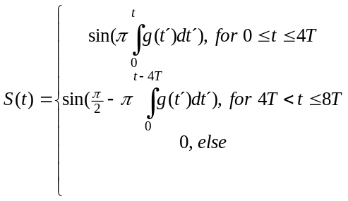
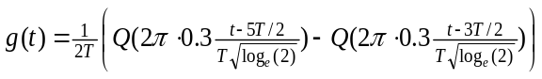
and
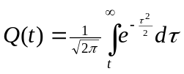.
The base band signal is
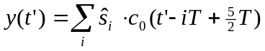
The time reference t' = 0 is the start of the active part of the burst as shown in figure 3. This is also the start of the bit period of bit number 0 (the first tail bit) as defined in GSM 05.02 [2].

3.6 Modulation
The modulated RF carrier during the useful part of the burst is therefore:
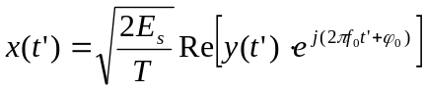
where Es is the energy per modulating symbol, f0 is the centre frequency and ϕ0 is a random phase and is constant during one burst.

Annex A (informative):
Change control history
SMG# | SPEC | VERS | NEW_VERS | PHASE | SUBJECT
S27 | 05.04 | 5.0.1 | 6.0.0 (Ph.2) | R97 | conversion to Release 97 EN
S28 | 05.04 | 6.0.0 | 8.0.0 | R99 | Introduction of 8PSK for EDGE
S30b | 05.04 | 8.0.0 | 8.1.0 | R99 | Correction of mistake for range alpha-sub-i in Clause 2.3
 |  | 8.1.0 | 8.1.1 |  | Figure 3 replaced (as it was corrupted)
G03 | 05.04 | 8.1.1 | 8.2.0 | R99 | Correction of symbol period notation
G04 | 45.004 | 8.2.0 | 4.0.0 | Rel-4 | New version for Release 4

